Order Of Service

Singing: Psalm 130—CW page 114

Reading: Psalm 5

Opening Hymn: CW 496

Reading: II Peter 3:14-18

Request Hymn: CW Supplement 748

Reading: Luke 24:1-12

Sermon Hymn: CW 363

Sermon Text: Song Of Solomon 3:7

Valiant Men

Prayer

The Apostles’ Creed, TLH page 12

Holy Communion

The Lord's Prayer

The Blessing

Closing Hymn: CW 245

* * * * * * * * * * *
Bible Study: Lambs: Philippians 4:4; Rejoice Always
Sheep: Provers 10:9-10; Your Choice
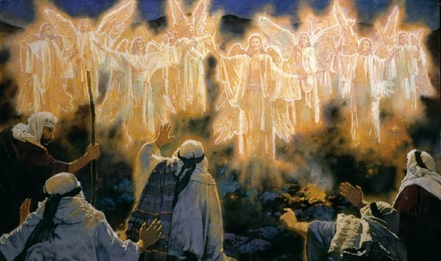

A Multitude of the Heavenly Host

Water
Of
Life

29 May 2016

W A T E R O F L I F E

Independent Christian Church—Conservative Lutheran Doctrine

Worship Service: 9:30 a.m. Bible Study: 10:45 a.m.

Larry Cooper, Pastor E-Mail address:
111 N. Ridge Road lcooper@wateroflife.cc
Coon Valley, WI 54623 Web Site:
Phone: (608) 452-2105 www.wateroflife.cc

* * * * * * * * * * * * * * * * * * * * * * * * * * *

Sermon Text: Song Of Solomon 3:7

Valiant Men

* * * * * * * * * * * * * * * * * * * * * * * * *

Song of Solomon 3:7 Behold his bed, which is Solomon's; threescore valiant men are about it, of the valiant of Israel.

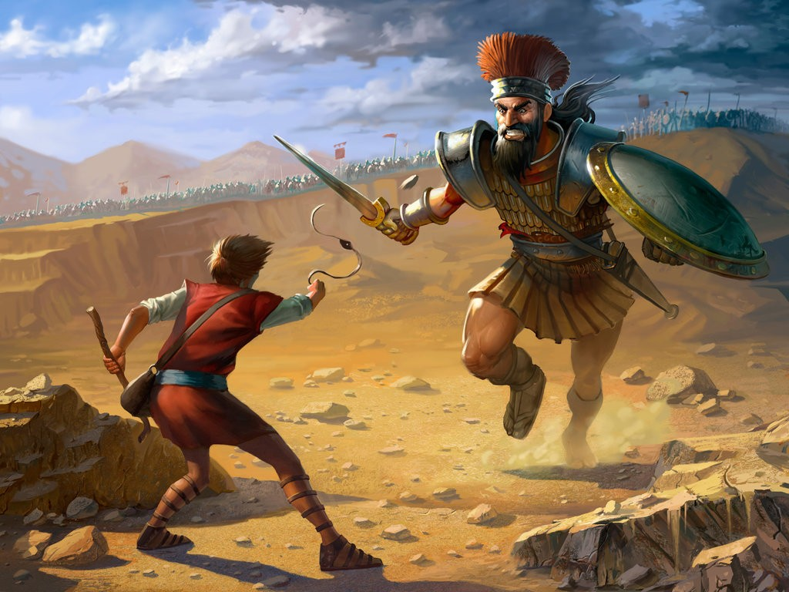
King David is a type of Jesus Christ. King Solomon is also a type of Jesus Christ. But each in a different way.

King David is a type of Jesus Christ in the Lord’s state of humiliation. He shows the Lord fighting against his enemies.

For David it all started down in the valley when he took the giant Goliath down with a sling and a stone which he had taken from the brook. But it didn’t end there. Throughout his adult life David was fighing and destroying his enemies and the enimies of his people. There was one battle after another. The Lord God was with David. And David had many valient men with him.

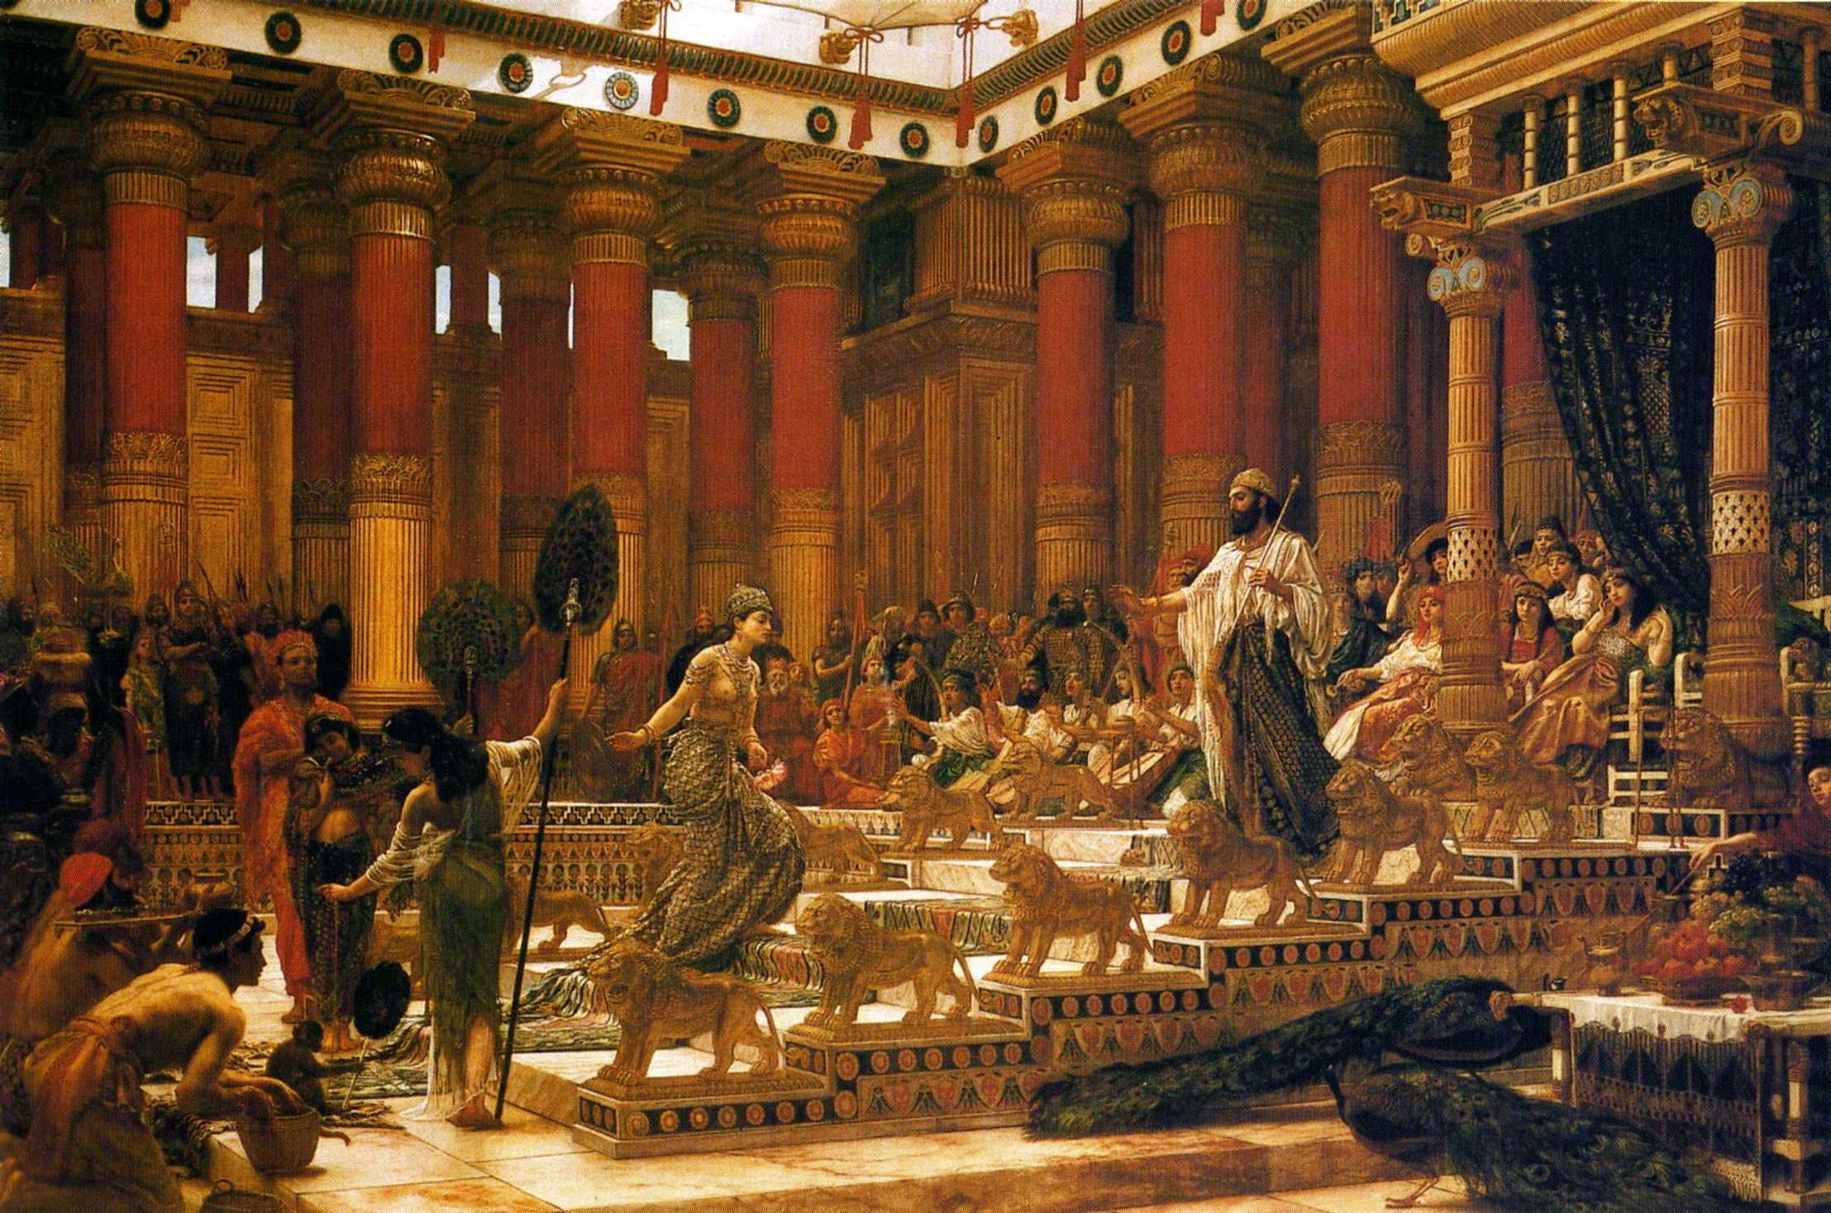

King Solomon is a type of Jesus Christ in the Lord’s state of exaltation. He shows the Lord in his Kingdom of Glory.

When Solomon began his 40 year reign most all of Israel’s enemies had been put down. So Solomon’s reign was one of peace and prosperity. The Lord God was with Solomon. And he, too, had many valiant men with him.

Notice also that here in the opening chapters of Song Of Solomon there are three beds mentioned:
# 1—“our bed”, 1:16
# 2—“my bed”, 3:1
# 3—“his bed”, 3:7

